**Accident Data Analysis Report**

**1. Introduction**

Traffic accidents pose a significant public safety challenge, affecting lives, infrastructure, and economies worldwide. This analysis explores accident data to uncover patterns, identify risk factors, and provide actionable insights to improve road safety. An interactive Tableau dashboard is utilized to analyze accident severity, vehicle involvement, weather conditions, and geographical distribution.

**Dataset Overview**

* **Source:** Accident data from 2019 (1,048,575 records)
* **Key Fields:** Date, Severity, Location (Latitude & Longitude), Light & Weather Conditions, Number of Vehicles, Number of Casualties
* **Objective:** Identify trends and contributing factors to enhance safety measures and inform policy decisions.

**2. Key Insights & Analysis**

**2.1 Accident Trends Over Time**

* **Observation:** The number of accidents varies throughout the year, with peaks during specific months.
* **Possible Causes:** Increased traffic volume during holidays, adverse weather conditions, and road maintenance schedules.

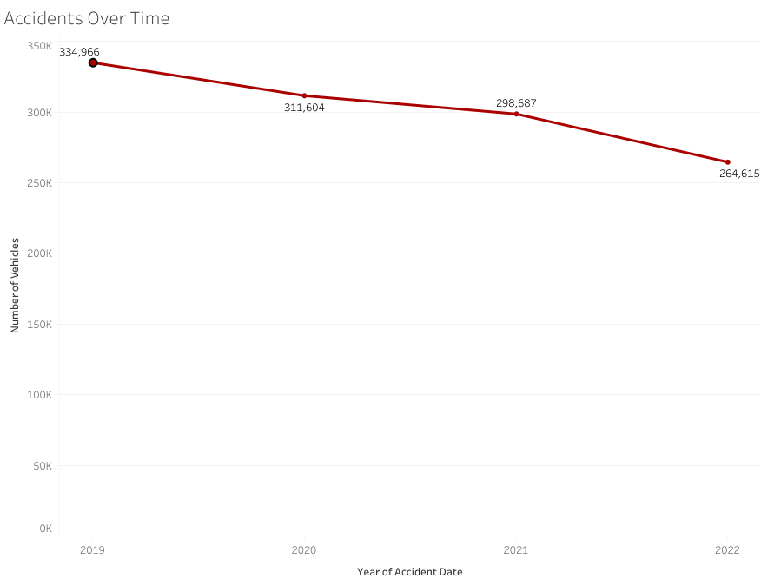

**2.2 Severity Distribution**

* **Observation:** The majority of accidents are categorized as **slight**, but a significant portion are **serious** or **fatal**, particularly under specific conditions.
* **Key Factors:** Road type, lighting conditions, and vehicle involvement contribute to accident severity.

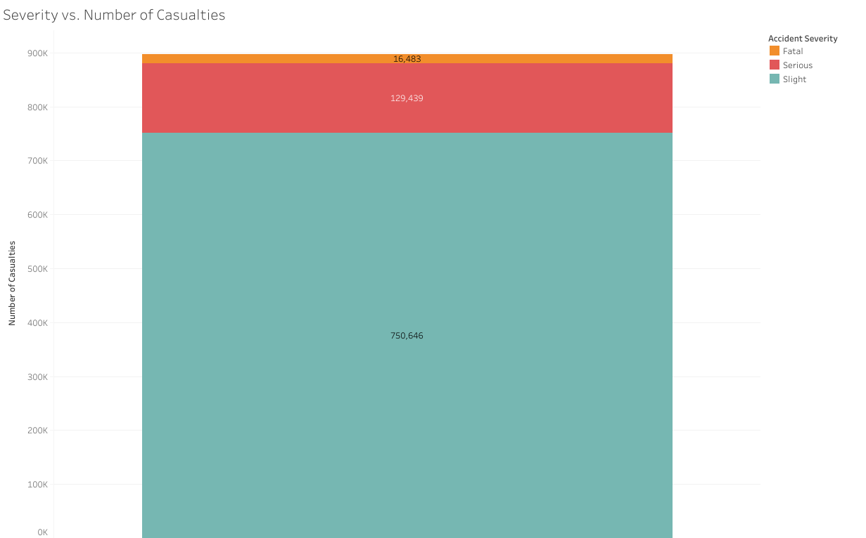

**2.3 Vehicle Involvement**

* **Observation:**
  + Multi-vehicle accidents are associated with higher casualty rates.
  + Fatal accidents are more frequent when heavy vehicles (e.g., trucks, buses) are involved.

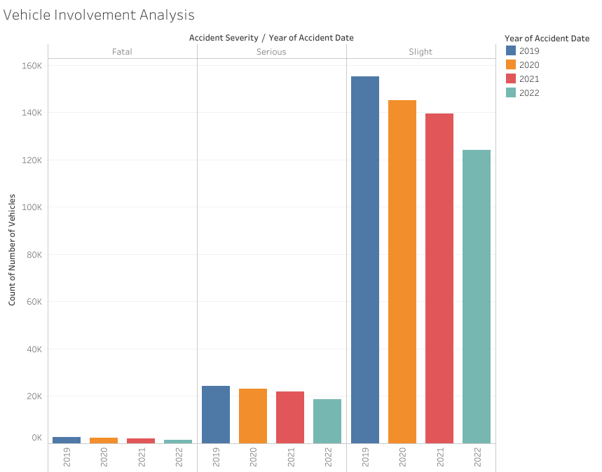

**3. Recommendations**

**3.1 Policy Changes for High-Risk Areas**

* Enforce stricter speed limits in accident hotspots.
* Improve road infrastructure, signage, and lighting in high-incident locations.

**3.2 Road Safety Enhancements Based on Environmental Factors**

* Upgrade drainage systems to mitigate accidents caused by heavy rainfall.
* Implement smart street lighting and reflective road markers to improve nighttime visibility.

**3.3 Regulations to Reduce Multi-Vehicle Accidents**

* Strengthen lane discipline and enforce traffic regulations for heavy vehicles.
* Conduct awareness campaigns to promote safe driving behaviors.
* Introduce adaptive traffic signals and dedicated lanes for heavy vehicles to reduce congestion-related accidents.

**4. Conclusion**

This analysis provides critical insights into the factors contributing to road accidents, emphasizing the importance of data-driven safety improvements. Implementing targeted interventions based on these findings can significantly reduce accident rates and enhance road safety.